DYNAMIC Culling Custom targetS

For DynamicCulling, you can define any custom object to cull and assign any behavior to it.

You need to attach the "DC_SourceSettings" component to the target object, set the Bounding Box for the visible area of the object and set the behavior for when the object is visible and when it is not.
Keep in mind that Dynamic Culling is a Raycast-based solution, so the Bounding Box you set for an object will later be replaced by a Box Collider. Therefore, objects behind this collider will be culled.

Let's configure the scene :
1) Create DC_Controller(Tools -> NGSTools -> Advanced Culling System -> Dynamic)

2) Disable "MergeInGroups" option in DC_Controller(this is needed for better demonstration in this scene. There are no restrictions on how this option works with Custom Targets)

3) DC_Controller -> Cameras tab -> Assign Auto

4) DC_Controller -> Renderers tab -> Assign Auto

Now we need to set up Custom Targets. In this scene these are Point Light and Particle System.

5) Attach the DC_SourceSettings script to Point Light.
6) You need to configure the Bounding Box for this source.
Warning! Specify only the visible part in the scene, not the Point Light itself. Image 1 shows an incorrect setting. Image 2 shows the correct setting.

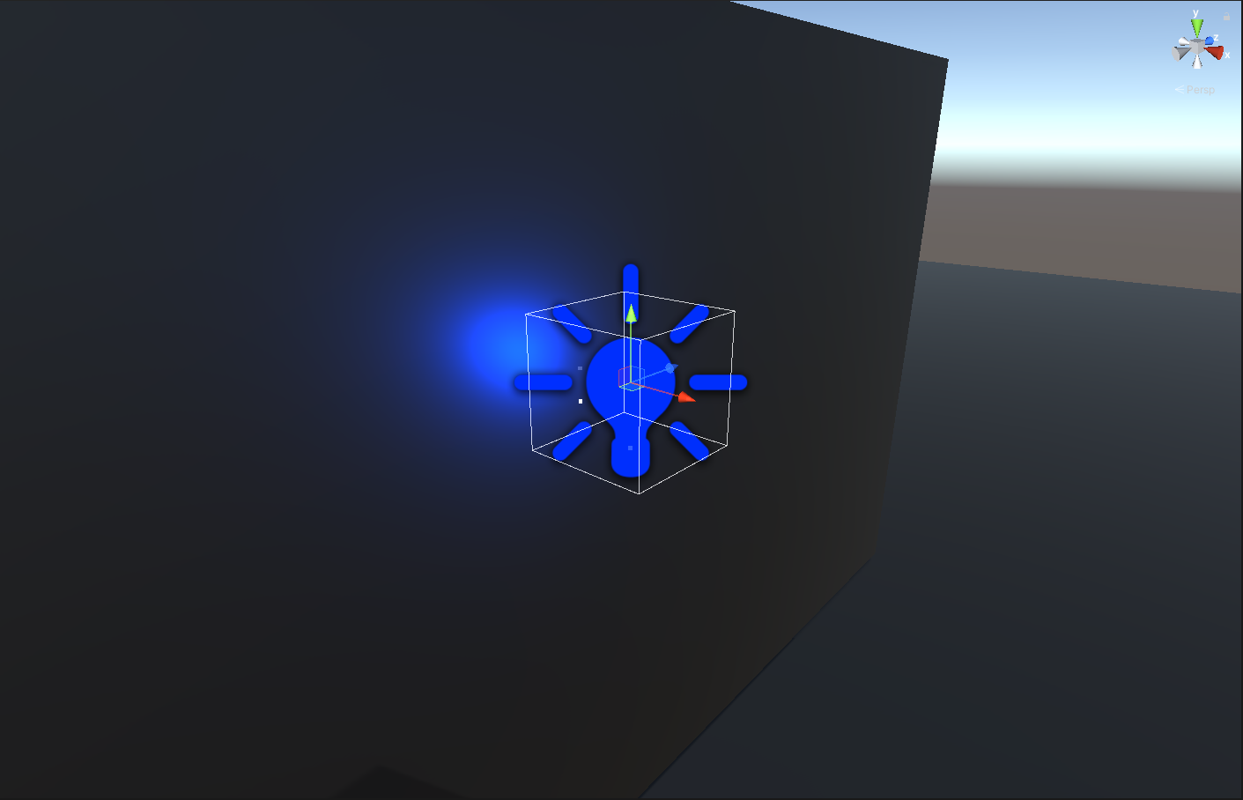
Image 1

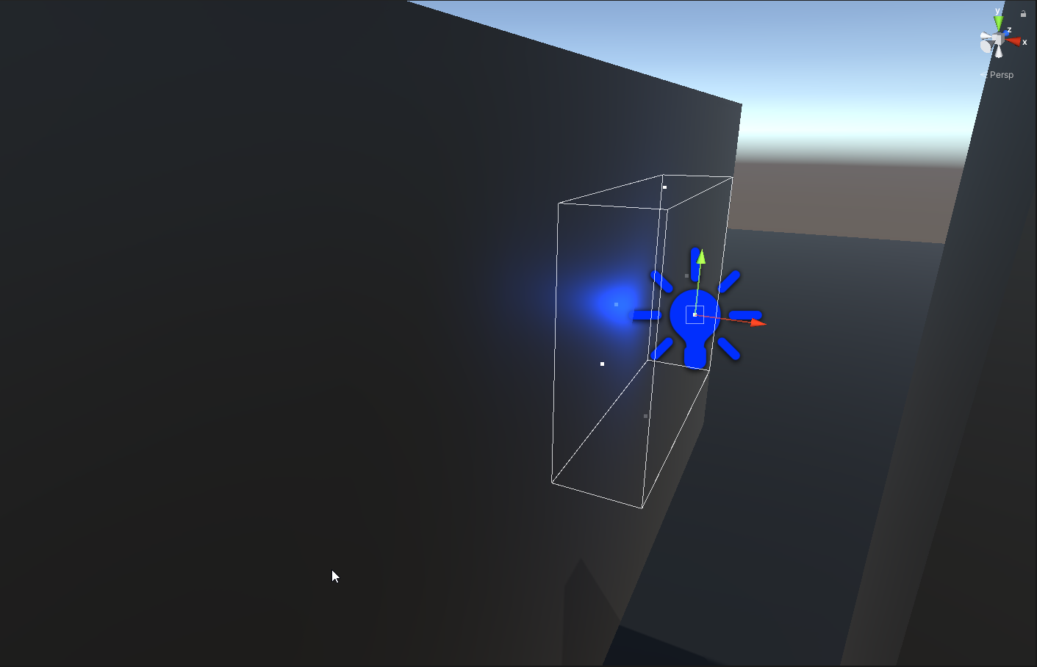
Image 2

7) Now configure the onVisible and onInvisible events in the DC_Source Settings component.(image 3)

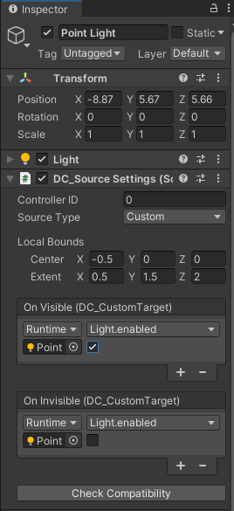
Image 3

8) Now let's configure the Particle System in the same way.
Attention! It is better to configure the Bounding Box as shown in image 4, not as shown in image 5. So that the Bounding Box contains only the visible part of the object and leaves as little empty space as possible.

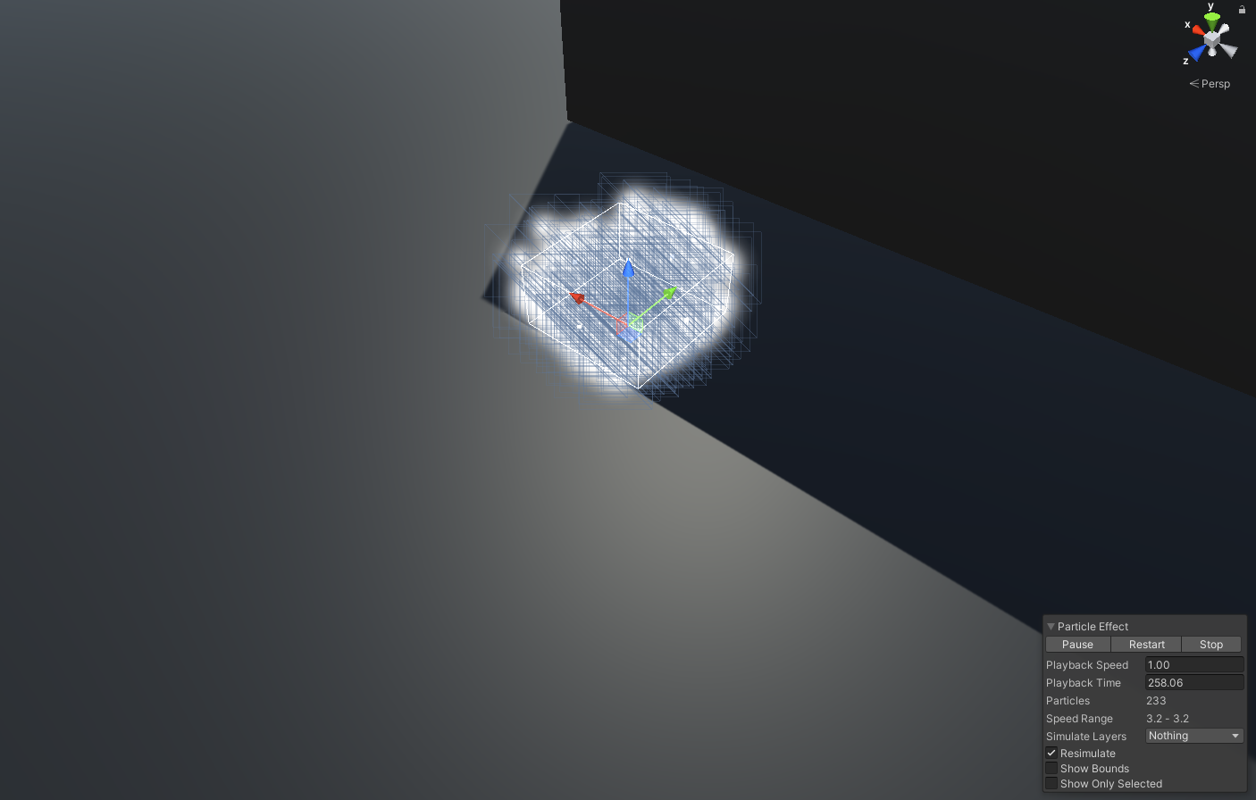
Image 4

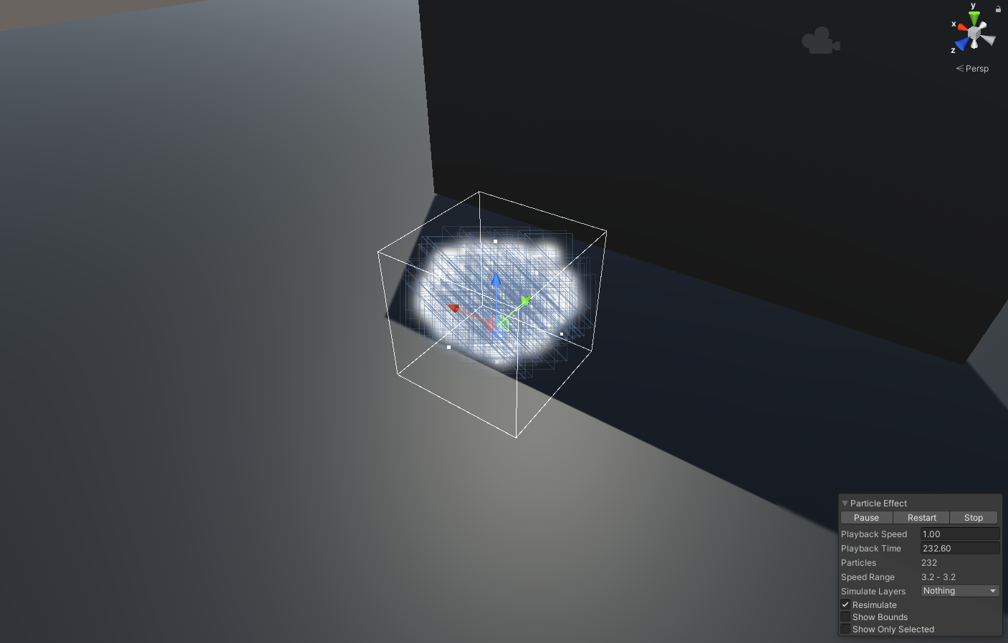
Image 5

9) DC_SourceSettings should look like this :

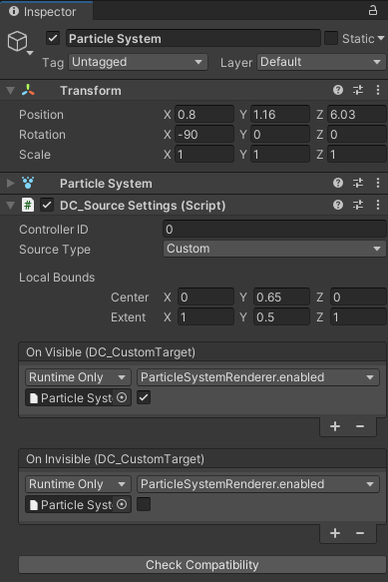
Image 6

10) You should now see two objects in the DC_Controller component in the Custom tab.

If you have set everything up correctly, invisible objects should be culled when you start the scene.

